Name: Class:
Introduction
Chapter 4 ‘Solutions’ introduces and uses many new terms and concepts. To help consolidate your understanding of these terms, complete the following glossary entries. For each entry you should use an annotated diagram and/or chemical equations to show the meaning of the term or descriptive phrase provided. You are not to write definitions; only diagrams and equations are required –be creative!

No. | Term/description | Diagram/equation(s)
 | Water is a V-shaped, polar molecule with intermolecular hydrogen bonds.
 | Molecules of NH₃ partially ionise when placed in water.
 | Water expands on freezing due to the nature of its intermolecular bonding.
 | The endothermic evaporation of water is utilised as a cooling mechanism.
 | Oil and water are immiscible liquids.
 | Ionic solids may dissociate in water, forming ion–dipole bonds.
 | Pentan-1-ol is less polar than ethanol. As a result, pentan-1-ol is less soluble in water than ethanol.
 | Because cyclohexane, C₆H₁₂ and oil are non-polar, when poured into the same beaker and stirred, they will form a homogeneous mixture.
 | The ion, [Cu(H₂O)₆]²⁺ is an example of a complex ion.

Which property of water is illustrated in the diagram shown below?

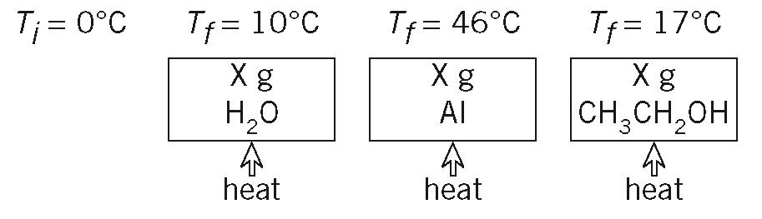
T_{i} = 0°C T_{f} = 10°C T_{f} = 46°C T_{f} = 17°C

